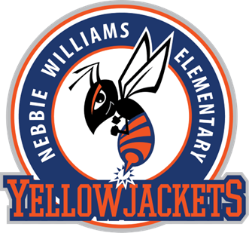

Vision Statement:

As a result of Nebbie Williams Elementary School’s counseling program, students will develop a sense of belonging with a voice to use to express their invisible needs and the empathy to recognize those needs in others.

Mission Statement:
The mission of Nebbie Williams Elementary School’s counseling program is to provide a nurturing and safe environment that addresses the academic, career, personal and social development of all students. The school counselor facilitates a support system to ensure all students recognize their full potential as a learner and have the skills and knowledge needed to be a successful citizen in our community.
